The concept and ways of implementing the primary health care reform

The Ministry of Internally Displaced Persons from the Occupied Territories, Labor, Health and Social Affairs having recognized the primary health care as the basis for the health care system where prevention, early diagnosis, effective management and long-term surveillance of the majority of medical problems can be performed, is starting active interventions to strengthen the PHC system. These interventions envisage introducing innovative methods to improve access to and quality of primary health care services. Primary health care reform involves improving both rural PHC services and optimizing primary health care services in big cities, which will increase system efficiency, help avoid unjustified costs and make the system more prevention-oriented.

What challenges will the current reform address?
The burden of non-communicable diseases is increasing in the country, which requires strengthening preventive services that will help people develop proper behavior and avoid health risks.
Today the primary health care system is focused on treating acute problems and less attention is paid to establishing healthy lifestyle and preventing. Due to limited diagnostic capabilities, the trust of population in PHC system is low, leading to irrational use of specialized services. Against the background of treatment with bypassing primary health care, overuse of drugs and overuse of high-tech research, the out-of-pocket health care costs remain high, which is a serious financial burden for both the individual patient and the community.
There is a clear need for strengthening human resources. To systematically enhance the competences of doctors and nurses, it is essential to activate continuous professional development system in all priority areas. The role of a nurse in the system is weak, which impedes teamwork.
The baseline quality indicators are not monitored in the PHC, so it is difficult to evaluate processes and outcomes. The links between PHC providers and specialists are weak, resulting in fragmented patient management.

PHC reform in rural areas

Problem-solving strategies and expected outcomes
Technical Strategy 1: Assignment of rural program management and coordination to the management of LEPL Emergency Situations Coordination and Urgent Assistance Center
Combining family doctors and nurses under a single management will ensure creating a network management capability for PHC and improving conditions for optimal use of resources.
To better coordinate and improve the quality of PHC services, it is important to decentralize the management model from central and regional to central, regional and district level. At the district level, the manager responsible for PHC management and coordination will be actively involved in organizing the practice, monitoring on-site service delivery and examining customer expectations and satisfaction.
Technical Strategy 2: Telemedicine and Digital Technologies for Clinical Decision Support

The role of digital technologies and telemedicine in improving access to and quality of medical services is increasing day by day. The new WHO guidelines issued in April 2019 specify the types of telemedicine and the way they be implemented at all levels of the healthcare system, including in the primary health care.
The guidelines emphasize the role of digital technologies and telemedicine in improving the quality of medical care. It is noteworthy that technology is seen as an auxiliary means-medical staff can be replaced in this way and the role of medical staff in the delivery of services remains crucial.
In Georgia the challenges in provision of outpatient and primary health care services (in particular, difficult geographic access, difficulty in receiving basic services in rural areas, weak referral links between specialists and rural doctors and fragmentation of the patient management process) can be successfully addressed through the implementation of telemedicine model, as well as strengthening laboratory capacities through automated analyzers in rural areas.
We consider expedient to use the following telemedicine models:
- Basic, when a family doctor participating in a rural physicians program will be able to communicate remotely with a specialist (e.g. within the framework of the outpatient service component of the universal access program). Ensuring online consultation opportunity for rural family doctors (with or without a patient) will make it easier to diagnose a range of acute illnesses and allow the family doctor to refer the patient differentially to a specialized doctor. It will also facilitate ongoing surveillance in the management of chronic diseases, as well as exchange of documentation, e.g. Form # 100 and prescription.
For technological support required to launch the basic model, it is necessary to provide both parties with computers and computer program for video calls and to save information about the patient according to the established procedure. The cost associated with the implementation of this model is minimal and is only associated with computer and internet costs.
- Second model is technologically complicated and envisages telecommunication between family doctors and specialists for diagnostics. This model will have more relevance in locations remote from district-level hospital, where patients find it difficult to visit district-level medical facility to consult a specialist.
Recommended diagnostic capabilities for on-site examination and subsequent transmission of data through telecommunication channels include telemedicine equipment with a spirometer stethoscope, otoscope, ophthalmoscope and dermoscope for general visualization. The use of 6-channel digital ECG is also important to timely exclude heart rhythm disorders and other pathologies.
To ensure efficiency, it is recommended to develop this type of digital service in outpatient clinics, which provide services to more than 3,000 inhabitants. A necessary prerequisite is the good condition of the outpatient facility and the interest and potential of medical staff to actively use in their work the available digital technologies.
- Third model implies the development of telecommunication capabilities between nurses employed in geographically difficult locations and family doctors in nearby outpatient clinics. It is advisable to equip a nursing unit with a patient monitor (for monitoring pressure, saturation and pulse electrographic data) and electronic scales (weight, height, mass index, visceral obesity and muscle development index). A digital stethoscope may also be used to timely diagnose pneumonia or other respiratory infections. In this case, a good condition of the outpatient facility and the interest and potential of medical staff to actively use digital technologies in the workplace are mandatory prerequisites. Also the possibility of providing internet connection.
Along with the use of telemedicine, it is recommended to use fully automated digital analyzers in outpatient clinics serving more than 3,000 inhabitants. In order to improve the diagnostic capabilities and management of chronic diseases at the level of the rural physician, it is recommended that an automated blood analyzer perform at least the following examinations:
- Clinical blood analysis
- Glucose in peripheral blood
- Creatinine
- Cholesterol in blood
- Determination of serum lipids: high density lipoprotein cholesterol, total triglycerides, low density lipoprotein cholesterol
- International normalized ratio (INR)
- Feces analysis for hidden bleeding,
- Prothrombin time (INR)
- Functional liver tests: ALT, AST
- Functional thyroid test TSH

Technical Strategy 3: Promotion of continuous professional development for physicians and nurses
The priority areas for continuous professional development program are chronic disease management, integrated HIV/AIDS, TB and Hepatitis C screening and integrated disease management; management of chronic obstructive pulmonary disease and bronchial asthma; palliative care and pain management. Early detection and management of diabetes mellitus; also programs aimed at promoting a healthy lifestyle.
Programs are being currently implemented and will be further expanded through state and donor funding.

Technical Strategy 4: Strengthening information systems and broad implementation of performance evaluation indicators

With the support of the World Health Organization, the Czech International Aid Agency/Czech Caritas and other local and international organizations, the Ministry works to develop and implement an electronic medical history and electronic records system for primary health care. Creating a unified patient database will allow us to see a patient's medical history and avoid unnecessary research when referring to another physician, as well as in case of gathering anamnesis will help us easily identify already diagnosed chronic diseases.

Technical Strategy 5: Revision and refining the rural program funding mechanism

The Ministry will work to improve the funding model of the rural program, which will focus on encouraging more patient-oriented and preventive services. Simultaneously to the development of information systems, work on outcome-oriented financing will begin. Currently, tuberculosis management service funding is implemented according to performance as a pilot project. This experience can be gradually extended to other services, e.g. management of hypertension and diabetes mellitus.

Technical Strategy 6: Activate the role of local government services in delivering PHC services in rural areas

It is important to identify and increase local government responsibility in terms of rehabilitation, maintenance, utilities and other infrastructure costs of PHC facilities.

See the details for implementation of rural PHC reform on the roadmap.
Figure 1 Roadmap for implementation of rural PHC reform

Priorities for primary health care reform in big cities
To optimize PHC services in big cities, the social service agency will use a selective contracting method. Under the Universal Access Program, a contract will be awarded based on the following criteria:
- Optimal number of population attached to 1 PHC team (physician/nurse) - <2,600 inhabitants, total number of population registered in the institution at least 13000.
- Provision of services to medical specialists and diagnostic services according to the actual address
- Provision of laboratory services (or extracting biological material) according to the actual address
- Requirements for infrastructure
- Immunization/participation in state immunization program
- Implementation and use of electronic records system
- Provision of continuous medical education
- Reporting on indicators of the quality of medical services (e.g. the quality of implementing preventive services, hypertension and diabetes management, etc.)

The new selection criteria will be announced in September 2019 (based on a government decree), they will become effective from March 2020 based on selection of service providers for more than 13000 beneficiaries. From 2021, the number of beneficiaries is planned to increase to 20,000.
The results of the selection criteria in Tbilisi, Kutaisi and Batumi are given in the table below. The map illustrates the distribution of large-scale establishments in Tbilisi that are likely to meet the selection criteria.

Figure 2. Selection results in Tbilisi, Kutaisi and Batumi
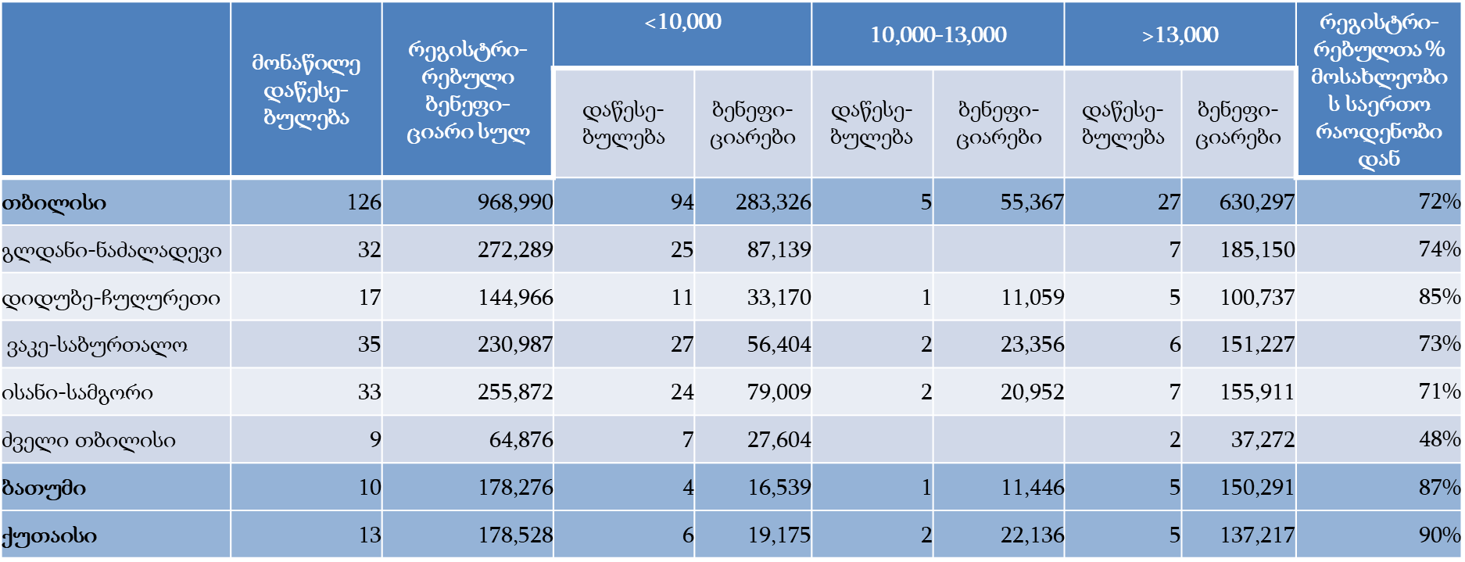
Isani-Samgori
Batumi
Kutaisi
Old Tbilisi
Vake-Saburtalo
Didube-Chughureti
Gldani-Nadzaladevi
Tbilisi
% of registered persons out of the total number of population
Beneficiaries
Institution
Beneficiaries
Institution
Beneficiaries
Institution
Total registered beneficiaries
Participating institution
Figure 3. Selection results in Tbilisi
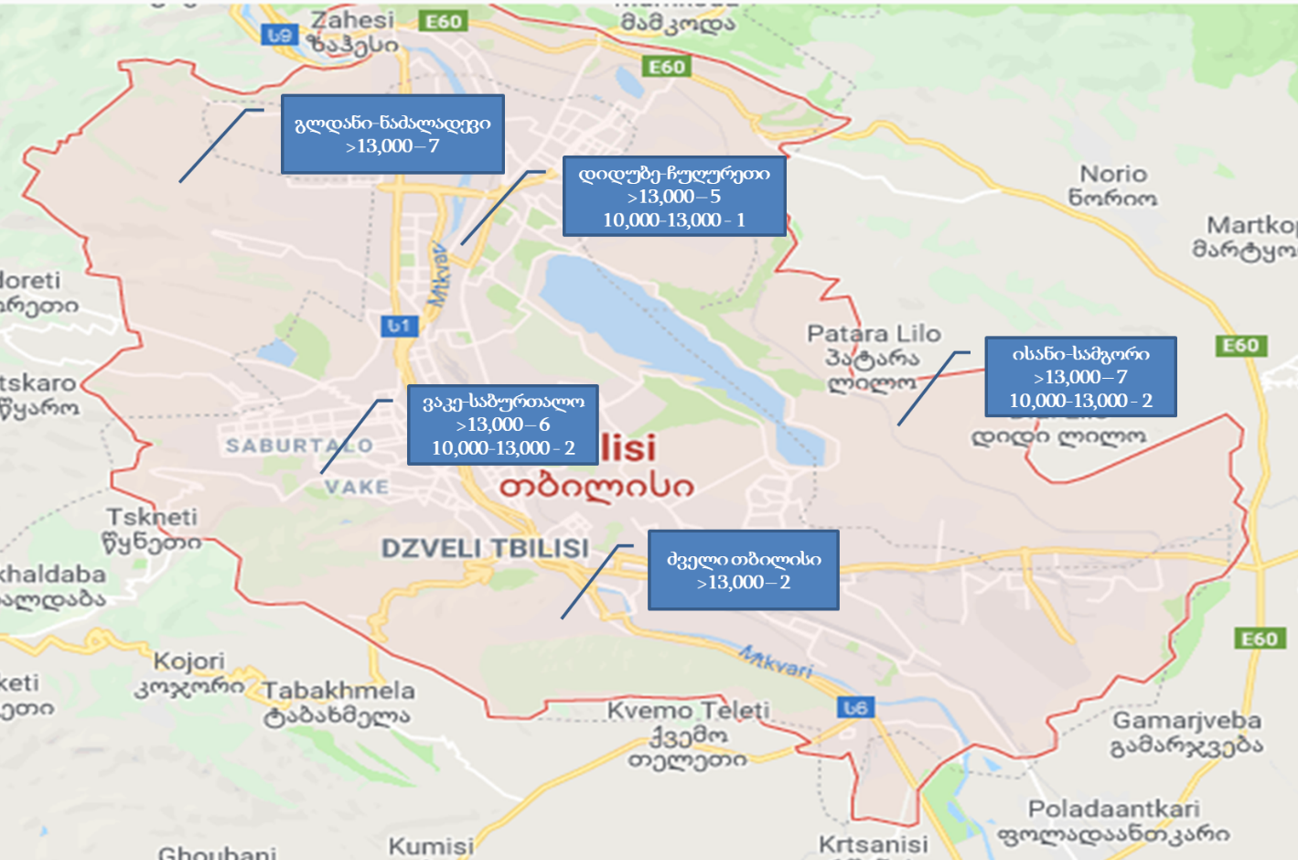
Old Tbilisi
Isani-Samgori
Vake-Saburtalo
Didube-Chughureti
Gldani-Nadzaladevi

Basic indicators of assessment of the success of PHC reform
Systematic indicators and target indicators | Basic data, 2017 | Target indicators
Systematic indicators and target indicators | Basic data, 2017 | 2019 | 2020 | 2021
Visits to primary health care institutions per capita | 3.6 | 3.7 | 3.8 | 3.9
Share of government spending on medicines out of the total volume of spending on medicines | 25% | 27% | 28% | 30%

LEPL “L. Sakvarelidze National Center for Disease Control and Public Health“. Health Care: A Statistical Guide. Georgia, 2017
The Ministry of Internally Displaced Persons from the Occupied Territories, Labor, Health and Social Affairs of Georgia. National Healthcare Reports. https://www.moh.gov.ge/ka/566/jandacvis-erovnuli-angariSebi

